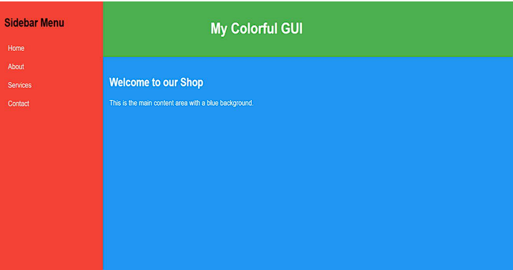
HTML Code
<!DOCTYPE html>
<html lang="en">
<head>
<meta charset="UTF-8">
<meta name="viewport" content="width=device-width, initial-scale=1.0">
<title>My Colorful GUI</title>
<style>
body {
margin: 0;
padding: 0;
font-family: Arial, sans-serif;
}
.sidebar {
background-color: #FF0000; /* Red */
color: white;
padding: 20px;
width: 200px;
height: 100vh;
float: left;
}
.header {
background-color: #006400; /* DarkGreen */
color: white;
padding: 20px;
text-align: center;
}
.content {
background-color: #0000FF; /* Blue */
color: black;
margin-left: 200px;
padding: 20px;
height: calc(100vh - 80px); /* Full height minus header height */
}
</style>
</head>
<body>
<div class="sidebar">
<h2>Sidebar Menu</h2>
<p>Home</p>
<p>About</p>
<p>Services</p>
<p>Contact</p>
</div>
<div class="header">
<h1>My Colorful GUI</h1>
</div>
<div class="content">
<h2>Welcome to our Shop</h2>
<p>This is the main content area with a blue background.</p>
</div>
</body>
</html>

